
Throughout Japan’s history, the country has experienced earthquakes and volcanic activity. Therefore, buildings have been particularly designed to deal with these disasters. The main types of buildings during Japan’s medieval times were: palaces, castles, shrines and temples.
Palaces and castles
Even though the Japanese and Europeans were on different sides of the world, they had similar ideas for building palaces and castles and defending them:
- several buildings connected by walkways
-large walls, barred windows, gates and trapdoors for protection
- moats (surrounding water) to prevent invaders digging in
-steep steps and narrow pathways to make attacking difficult
- portholes for archers to fire out of
-built on a hill to have a better defence and a lookout
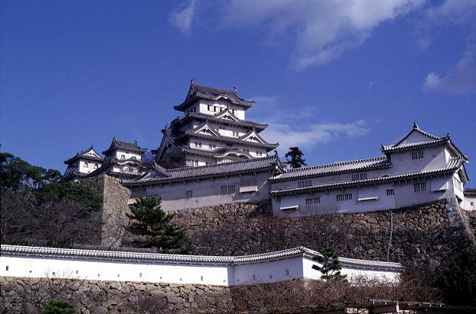
Source: The Himeji Castle (also known as the White Heron Castle)
Built in 1557 by Samurai: Toyotemi Hideyoshi
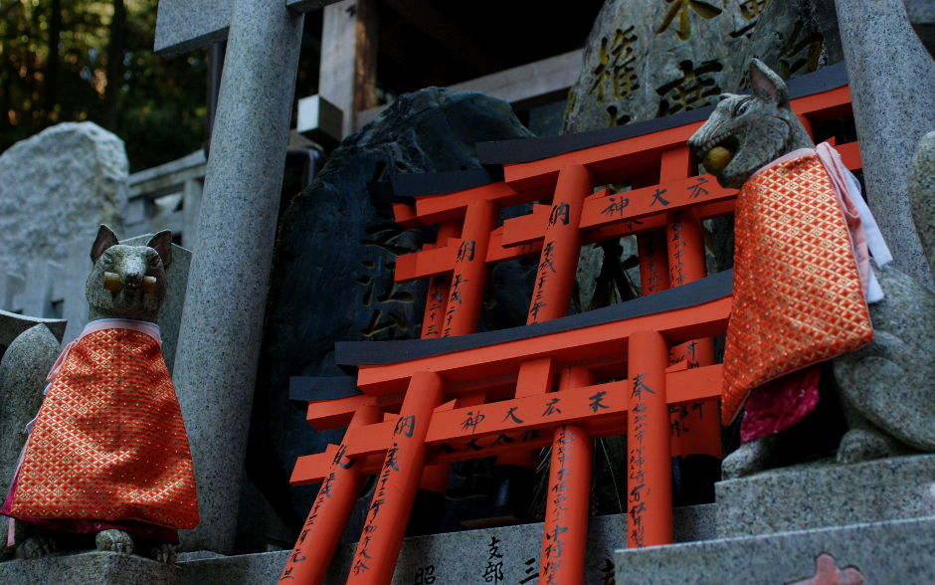
Shinto and Buddhist Architecture
In early times, the Shinto religion had no buildings or shrines. Instead they had simple shrines which were rocks and trees which were hung up by rope. With the passing of time, the shrines were then made from simple wood and placed in a natural garden setting. No statues were allowed to represent any of the gods, but sacred stone animals were placed in front of the shrine to protect it.
Source: Guardian animals protecting Shinto Shrine.
While Shinto shrines were simple, Buddhist temples were ornate and elaborately decorated. The earliest temples in Japan were influenced by Chinese architectural styles as can be seen with the Horyuji temple which was built in 607 A.D. (See picture below)
